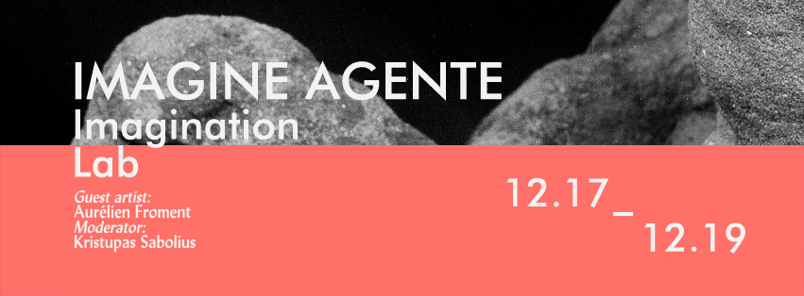

Workshop on the practices of imagination in art and philosophy.

December 17
19.00 Screening of Aurélien Froment’s films, followed by the Q&A with the artist.
CAC cinema. Vokiečių 2, Vilnius.
Open to the public.

December 18
10.00 – 15.30 Imagination lab.
Actual and virtual heroes: Aneta Rostkowska, Karolina Žernytė, Myriam Lefkowitz, Audrius Mickevičius, Joshua Oppenheimer, Pierre Huyghe, Marcos Lutyens, Joris Lacoste, Catherine Contour, Julijonas Urbonas, Carlos Reygadas, Apichatpong Weerasethakul and others.
Vilnius University. Limited Attendance.
Registration needed at: imagine.agente@gmail.com

16.00 Imagine Agente. Artist talk with Aurélien Froment, moderated by Kristupas Sabolius.
La Médiathèque, Institut français de Lituanie, Didžioji 1, Vilnius.
Open to the public.

December 19
10.00 – 17.00 Imagination lab.
Actual and virtual heroes: Aneta Rostkowska, Karolina Žernytė, Myriam Lefkowitz, Audrius Mickevičius, Joshua Oppenheimer, Pierre Huyghe, Raimundas Malašauskas, Marcos Lutyens, Joris Lacoste, Catherine Contour, Julijonas Urbonas, Carlos Reygadas, Apichatpong Weerasethakul and others.
Vilnius University. Limited Attendance.
Registration needed at: imagine.agente@gmail.com

This research was funded by a grant (No. MIP-086/2013) from the Research Council of Lithuania. Kristupas Sabolius also wants to express his appreciation to Institut français de Lituanie and Contemporary Art Centre (Vilnius).

