„Biopolitics in the Context Of Contemporary Philosophy, Politics and the Arts“
Contemporary Art Centre, Vilnius, September 20 – 22

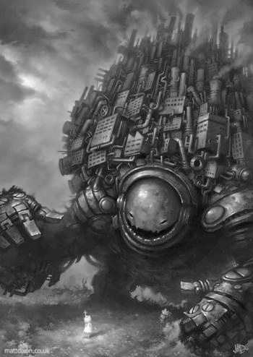
Matt Dixon. Mašina. http://www.mattdixon.co.uk/
THE CONFERENCE PROGRAMME

Thursday, 20 September

10:00 – 13:00 Biopolitics In Philosophical Tradition
10:00 Naglis Kardelis
The Prototypes of Biopolitics in The Ancient World
10:45 Coffee Break
11:15 Gintautas Mažeikis
Procedures of Cleansing of Body Consciousness
12:00 Discussion. Biopolitics in Philosophical Tradition: Genealogy of Confinement
13:00 – 15:00 Lunch Break

15:00 – 18:00 Biopolitics in Art
15:00 J. D. Mininger
Sliding Down the Surface of Things: Allegories of the Biopolitical in Bret Easton Ellis’ Glamorama
15:45 Coffee Break
16:15 Stephen Zepke
'New Ears for New Music' - Nietzsche, Art and Biopolitics
17.00 Discussion. Biopolitics In Art: „Post-human“ Will and Fragmentary Values

Friday, 21 September

10:00 – 13:00 Biopolitics in Politics I. Sovereignty, Negative Biopolitics, Bare Life
10:00 Joanna Bednarek
Polish Crises of (Material and Symbolic) Reproduction: Free Culture, Economy of Care and Three Types of Protest
10:45 Coffee Break
11:15 Marina Grzinic.
What to do with Biopolitics in the Times of Necropolitics?
12:00 Discussion. The Negative Biopolitics. Sovereignty, Necropolitics and Life In Eastern Europe.

13:00 – 15.00 Lunch Break

15:00 – 18:00 Biopolitics In Politics II: Strategies of Resistance
15:00 Kasparas Pocius
State of Exception or Divine Violence? Strategies of Resistance in Eastern Europe
15:45 Coffee Break
16:15 Audronė Žukauskaitė
Beyond the Biopolitics Principle: On Impotentiality
17:00 Discussion. The Affirmative Biopolitics: Potential Strategies of Resistance

20:00 Film Presentation. „Barzakh“ by Mantas Kvedaravičius
http://www.barzakhfilm.com/

Saturday, 22 September

10:00 – 14:00 Biopolitics, Media, Imagination

10:00 Mantas Kvedaravičius
Facing
10:45 Nida Vasiliauskaitė
Sexual Nationalism: "I Love Lithuania"
11:30 Coffee Break
12:00 Nick Thoburn
Biopolitical Publishing: A Diagram of the Political Magazine
12:45 Discussion. Biopolitics and Media: Reclaim Our Imagination, Reclaim Our Lives.
13:45 Concluding Remarks.

Conference is organized by Lithuanian Culture Research Institute, sponsored by Research Council of Lithuania and Contemporary Art Centre

