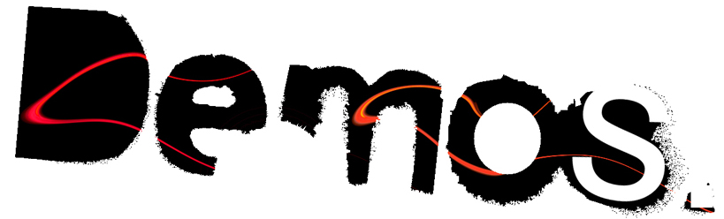
kritinės minties institutas

DEMOS institute of critical thought
In association with LUNI, Vilnius

‘The present state of labor and the future of political praxis’
A public seminar hosted at ŠMC, Vilnius

A political-philosophical project to reevaluate labor and new possibilities for democracy

Organized jointly by Andrius Bielskis and J.D. Mininger, this project brings together a diverse group of professional scholars, public intellectuals, and politically engaged citizens to examine foundational theoretical texts, recent studies of globalization, urgent theories of labor, and the potential and emergent forms of democratic collectivity and power attendant to the situations that these theories describe and analyze.
This diverse intellectual collective will convene once a month, on the 17th of each of months of February, March, and April, 2010. These seminar sessions are open to the public and free of charge. Any and all are encouraged to attend and participate!
Each seminar session will be organized by a common reading, and each session will include at least two prepared commentaries from experts in the chosen field (e.g. political philosophy; labor law; political science and diplomacy; etc.). Each session has a two-fold goal: 1) to collectively read, comprehend, and analyze the chosen text through commentary and open discussion; 2) to place the collectively pursued and inevitably plural insight from the textual study into the Lithuanian context, and to debate the stakes and results of these theories from this local application. (See schedule below for further details.) The intent of the sessions’ structure is to create a participatory seminar-style atmosphere, in which all voluntary contributors cooperate to interpret the texts, ideas, questions, and problems at hand. The role of scheduled speakers is not as teachers speaking ex cathedra, but as instigators, provocateurs, and starting points for organic discussion. For more information or to request copies of the readings, please contact J.D. Mininger (j.mininger@pmdf.vdu.lt) or Andrius Bielskis (andriusbielskis@hotmail.com). The language of the seminars will be English.

Schedule
18.30, Wednesday, 17th of February 2010
Topic: Old Ideas, New Labor: ‘Marx Beyond Marxism?’ Critical Foundations in Modern Contexts
Reading: Karl Marx, Grundrisse (London: Penguin Books, 1993), 690-712.
Speakers:
-- Gintautas Mažeikis: “A Historical and Rhetorical Introduction to Grundrisse”
-- J.D. Mininger “The Coming Community of Communicative Labor: a Close Reading of Marx’s so-called ‘Fragment on Machines’”
-- Andrius Bielskis: “On Labour and Practice: XXI Century Concerns”

18.30, Wednesday, 17th of March 2010
Topic: ‘How the Multitude Works’: Contemporary Forms of Labor
Reading: David Harvey, (2005), A Brief History of Neoliberalism, (chapter 1) “Freedom’s Just Another Word”.
Speakers:
-- Simon Rees: On Cultural Labor as Slavery: a response to Hardt and Negri’s “The Dialectic of Colonial Sovereignty” in Empire.
-- Artūras Tereškinas: On the Hardships of Lithuanian Working-class Men

18.30, Wednesday, 17th of April 2010
Topic: Multitude and the future of political praxis
Reading: 1) Michael Hardt & Antonio Negri, Multitude (selections still to be determined) from the section “Democracy,” pp. 231-358
Speakers:
-- J.D. Mininger “Spinoza and the Politics of the Common”
-- Audronė Žukauskaitė On Deleuzean Multiplicity & Minor Politics
-- Andrius Bielskis: Seminar wrap-up

